March 20, 2020

Dear Cole Center Family YMCA;
At the Cole Center Family YMCA, the safety and well-being of our members, staff, volunteers and the broader community have always been and will always be a top priority.
To fulfill our mission to be socially responsible, the Cole Center Family YMCA will be closed effective 8:30pm on Friday, March 20th, 2020. The only exception to closure at this time is our childcare services. We believe that supporting our working parents and medical staff is of paramount importance during this tumultuous time. If you or someone you know are in need of childcare in order to go to work, please contact us at 260-347-9622. We are working hard with community partners to explore ways that we can support families in a safe way.

Additionally, during closure, we will be conducting a deep cleaning and disinfecting our facility prior to reopening.
During this difficult time, we ask that you stick with us and continue your membership. Your membership fees will allow us to continue to serve our community, maintain our facility for your return, and support our staff while they are out of work. While we recognize continuing your membership is not a viable option for every family, we are asking you to support your Y during this time. If supporting your Y is not an option for you, please contact us at 260-347-9622 to discuss options around your membership fees.

To help you and your family be well, we will be rolling out online, home-based exercise classes, cooking-at-home ideas, and youth enrichment activities for our community early next week. These resources will be posted via our website www.coleymca.net, social media, and YouTube channel.
We are hopeful that these significant precautions will help stem the spread of the virus and that we can begin to return to our normal routines soon. We are going to miss you!
Thank you. We are praying for the health and well-being of your families.

Thank you,
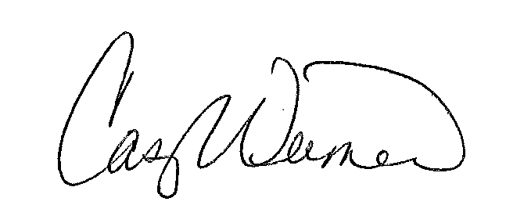

Casey Weimer
CEO/ Executive Director

